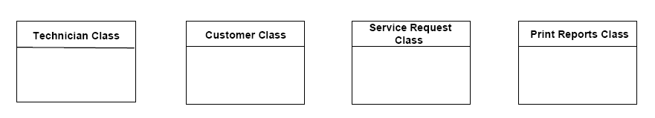
Figure 1: First iteration of class diagram.

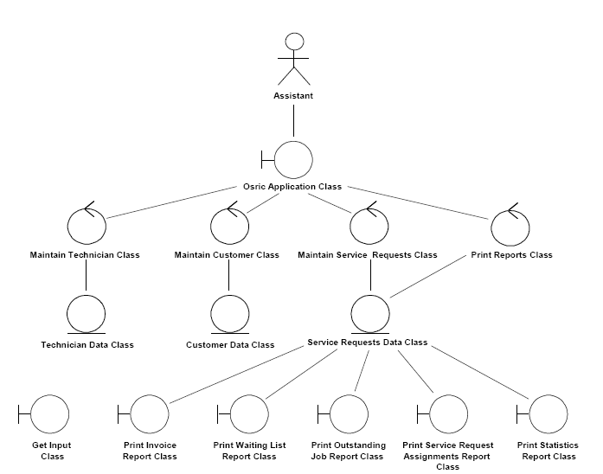
Boundary class
control class
entity class
Figure 2: Second iteration of the class diagram drawn to show stereotypes

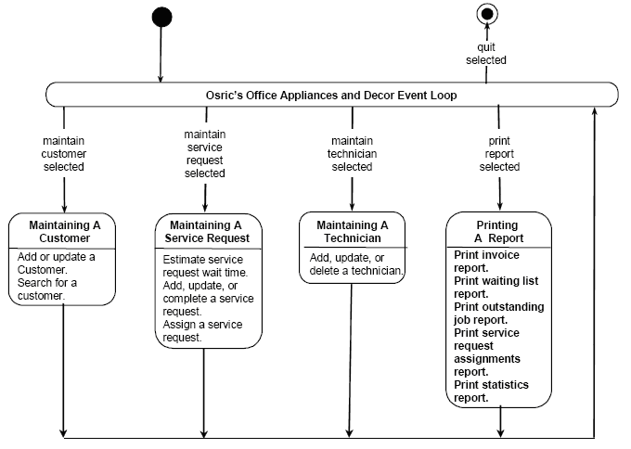
Figure 3: First iteration of the statechart
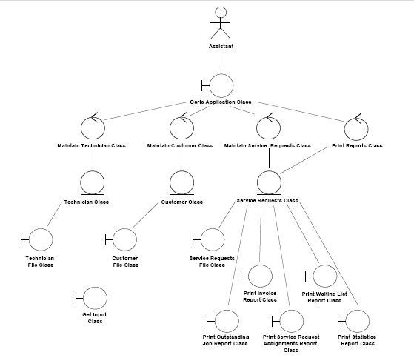

Figure 4: Third iteration of the class diagram

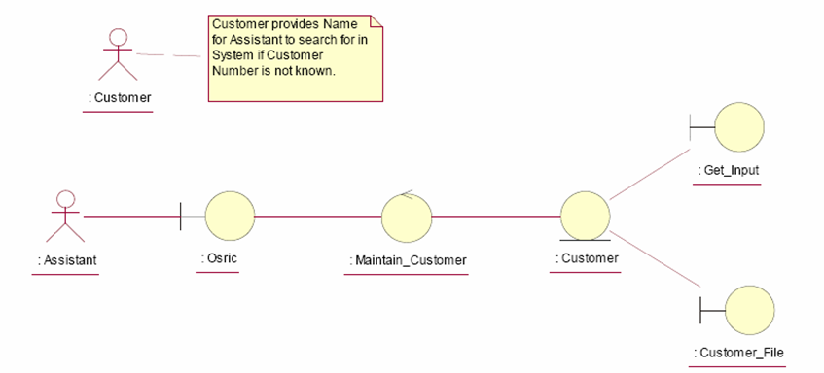
Figure 5: Class diagram showing the classes that realize the Search Customer
use case. As stated at the beginning, IBM Rational Rose incorrectly depicts
actor Customer as an instance of the (non-existent) Customer Class and Actor
Assistant as an instance of the (non-existent) Customer Class.

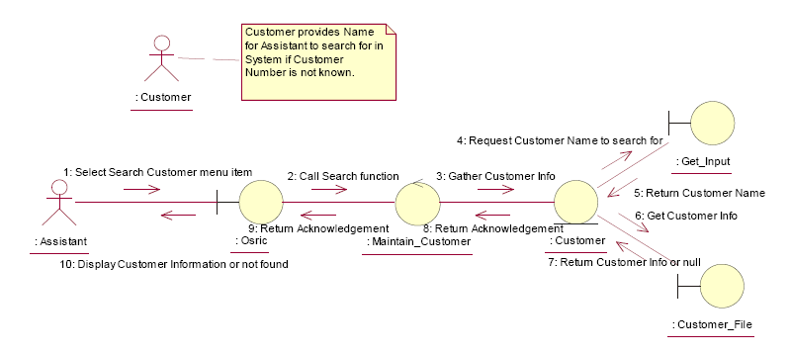
Figure 6: A collaboration diagram of the realization of the extended scenario of
of the Update Customer use case

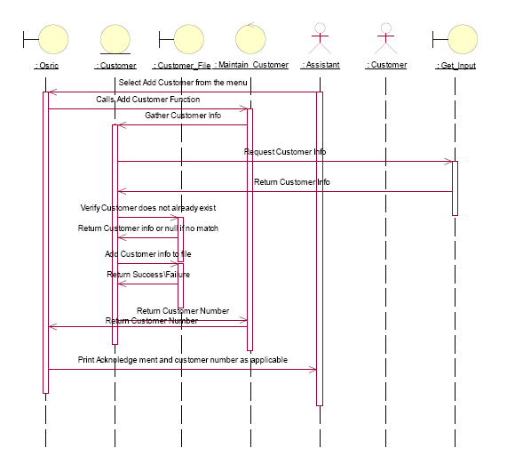
Figure 7: A sequence diagram equivalent to the collaboration diagram of Figure 6.

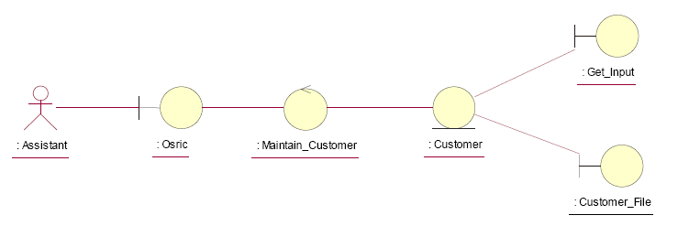
Figure 8: Class diagram showing the classes that realize the Update Customer use case.

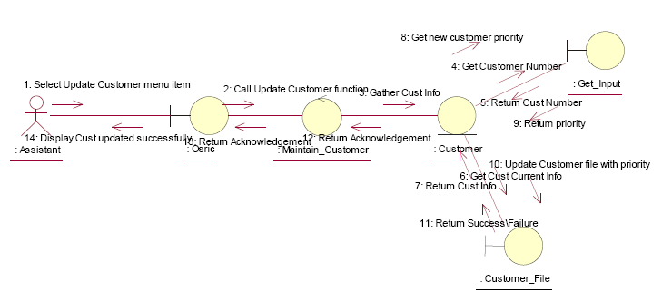
Figure 9: A collaboration diagram of the realization of the extended scenario of the Update Customer

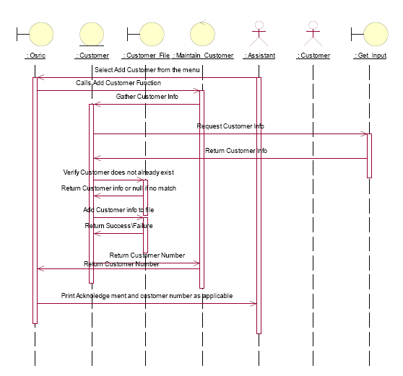
Figure 10: A sequence diagram equivalent to the collaboration diagram.
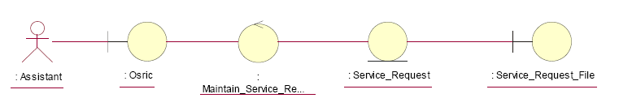
Figure 11: Class diagram showing the classes that realize the Update Customer Priority use case.

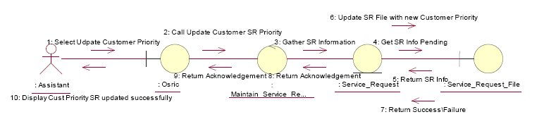
Figure 12: A collaboration diagram of the realization of the extended scenario of the Update Priority use case.

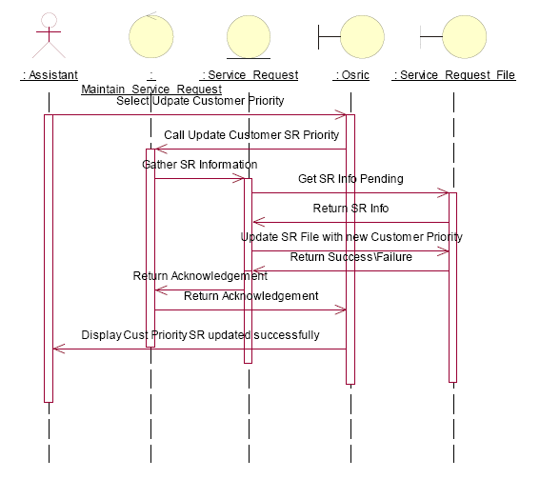
Figure 13: A sequence diagram equivalent to the last collaboration diagram.

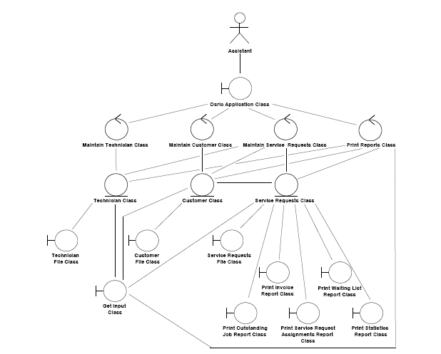
Figure 14: Fourth iteration of the class diagram.

